***Email Verification***

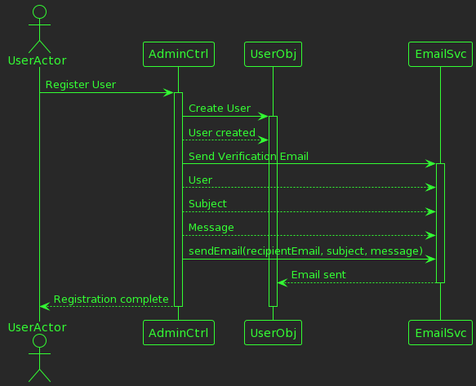

@startuml

!theme crt-green

!define ADMIN_CONTROLLER class AdministratorController [[java:edu.sru.thangiah.controller.AdministratorController]]

!define EMAIL_SERVICE class EmailService [[java:edu.sru.thangiah.service.EmailService]]

!define USER class User [[java:edu.sru.thangiah.model.User]]

actor UserActor

UserActor -> AdminCtrl: Register User

activate AdminCtrl

AdminCtrl -> UserObj: Create User

activate UserObj

AdminCtrl --> UserObj: User created

AdminCtrl -> EmailSvc: Send Verification Email

activate EmailSvc

AdminCtrl --> EmailSvc: User

AdminCtrl --> EmailSvc: Subject

AdminCtrl --> EmailSvc: Message

AdminCtrl -> EmailSvc: sendEmail(recipientEmail, subject, message)

EmailSvc --> UserObj: Email sent

deactivate EmailSvc

AdminCtrl --> UserActor: Registration complete

deactivate UserActor

deactivate AdminCtrl

deactivate UserObj

@enduml